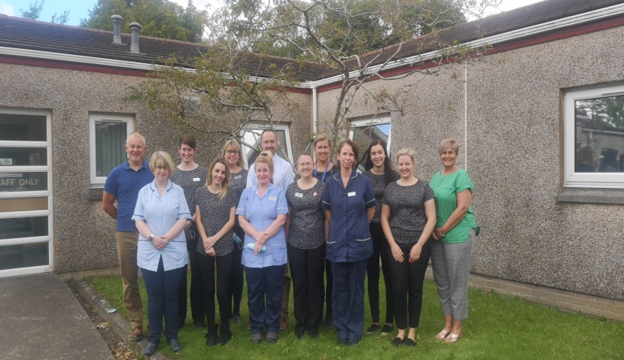
GALLOWAY HILLS MEDICAL GROUP
PRACTICE NEWSLETTER OCTOBER 2020
We hope you are all keeping well and staying safe. This has been an unprecedented time for us all and unfortunately we are no clearer on timescale of this virus subsiding therefore it is necessary for us to keep all our safety measures in place throughout the winter period in order for us to continue to provide a service to you. We are sure that you are all aware that these measures are essential to keep you and our staff safe.
We would like to reassure you that we are always contactable every weekday between 8am and 6pm and if the clinician feels you need to be seen in the surgery we have safety measures in place for this to be done.
At the end of October Dr Sandra Sutherland will be retiring from the practice. Dr Sutherland has been a partner in the practice for 24 years and she is going to be missed by us all. We would like to thank Dr Sutherland for her dedication and service to the practice and wish her best wishes for a long and happy retirement.
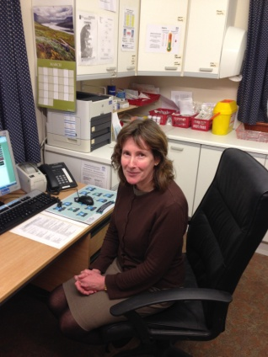
Due to the reduced clinician capacity we have required to make changes to the way we provide our services to you. Covid has taught us that it is not always necessary to see patients face to face for a consultation and the necessity of using telephone consultations has given us the opportunity to enhance our telephone consultation service. Over the past few weeks we have taken the opportunity to ask our patients who have used the telephone consultation service a few questions on their experiences using the service:-

Q. Were you satisfied with your consultation?
A. 100% of patients were satisfied with their consultation
Q. Did you get answers to your problem?
A. 91% of patients answered yes
Q. Did you require to see a clinician for a face to face appointment after the consultation
A. 28% of patients required to see a clinician after the telephone consultation
Q. Could the service be improved
A. 86% of patients surveyed said no they were happy with the service.

What our patients are saying:-
“I was really impressed with how much time was taken to answer all my questions”
“telephone consultation was ample for my problem”
“very satisfied with my telephone consultation”

Let us take a few minute to explain to you how our service works:-
- You telephone the practice for any appointment
- Our reception staff have been trained to ask you for some details of your symptoms in order to direct you to the most appropriate clinician - this might not always be a GP it could be our fully trained advanced nurse practitioners, practice pharmacist, practice mental health worker, paramedic or even out with the practice team i.e. community pharmacist in the chemists, opticians or dentist. PLEASE BE POLITE AND UNDERSTANDING TO OUR RECEPTION STAFF who are doing the task they have been asked to do by the clinical team.
- You will then be offered a 15 minute telephone consultation with a member of the clinical staff. This will be a thorough consultation and at the end of this if the clinician feels you need to be seen for a face to face consultation they will offer you a time (the same day if urgent) to come into the surgery to be seen – with safety measures in place.
- If the clinician feels they need to see you for a face to face consultation that is not urgent we will be offering sessions in our three sites at various times throughout the week (this may be subject to change at short notice due to conforming with Covid restrictions). These appointments will be made be a clinical member of our team after the initial telephone consultation.
If, having spoken to a clinician, you are issued with a prescription we do have a system where we can email the signed prescription to the chemist of your choice so that there is no delay in you receiving your treatment. If this happens to you please arrange to pick up your prescription after 4pm on the day that it was issued. If it is a repeat prescription please allow a week between ordering your prescription from us to collecting from the chemist or dispensary in Kirkcowan.
If you have any questions please do not hesitate to contact our reception team who will be happy to help you.
At all times we will follow the Government regulations and the current Covid guidelines and this may require us to make decisions quickly for the safety of our staff and patients. We are required to sterilise each of our clinical rooms every time a patients has been seen therefore we need to allow extra time between patients for this. This means that we have less appointments to offer at the moment for routine blood tests/dressings etc. but we are sure you understand the necessity for these strict cleaning regimes. We are also controlling access to our buildings to reduce the risk of spreading the virus. We are limiting the number of patients allowed into the buildings at one time. We appreciate during the cold, winter months, this could cause difficulties and ask for your patience and understanding . However, please remember there are ways to access us without the need to come into the surgery and we would ask that you consider this before entering the buildings:-
If you are seeking medical advice:-
The NHS inform website www.nhsinform.co.uk has up-to-date medical information for you
Or you can telephone the reception team who will direct you to the most appropriate person to deal with your problem.
REMEMBER WE ARE OPEN MONDAY-FRIDAY 8AM-6PM TO HELP YOU.
If you require a repeat prescription
You can put your reorder slip through the designated letter boxes in all of the three sites, you could hand into your local chemist shop or you could order online through Patient Access. If you are not registered for this please contact reception and they will email you a registration form.
If you require results of tests
You can telephone the surgery after 2p.m and you can get your results. If the clinician requires to speak to you a telephone consultation will be made for you at this time.
If you need to hand in a sample
Please ensure all your details are clearly labelled on the envelope and simply post in the letterboxes of the surgeries – bearing in mind the opening times of each place.
Opening times of each surgery:-
Kirkcowan
Monday/Tuesday/Thursday 8am – 1pm
Wigtown
Monday/Tuesday/Thursday/Friday 8am – 1pm
Newton Stewart
Monday/Tuesday/Wednesday/Thursday/Friday 8am – 6pm

If you are handing in samples these need to be in before 12pm in order for them to be processed that day. Please only hand in samples on the days when the surgery is open or these will need to be destroyed.
If you need a sick note
You can telephone the practice and we can either post these out to you or email them.
NHS Dumfries and Galloway will be delivering the flu vaccinations for all eligible patients in 2020.
- People aged over 65 (in December, people over 55 will also be included)
- Pregnant woman
- People in “at risk” categories
- Covid-19 shielding patients and household members
Eligible adults will receive an appointment letter with the date, time and venue and a telephone number to rearrange if needed.
School children will be receiving their Nasal Flu at school. Pre-school children aged 2-5 will be receiving an appointment to have this done at the surgery.
We are actively searching for another GP to join our team. We are currently advertising and working alongside other Wigtownshire practices to host a virtual recruitment event in November. Have a look here https://apply.jobs.scot.nhs.uk/displayjob.aspx?jobid=32179 then go to the bottom of the page and click on virtual GP recruitment event brochure.

TRY TO REMEMBER AT THIS CHALLENGING TIME:-
YOU ARE NOT ALONE - TOGETHER WE WILL GET THROUGH THIS

